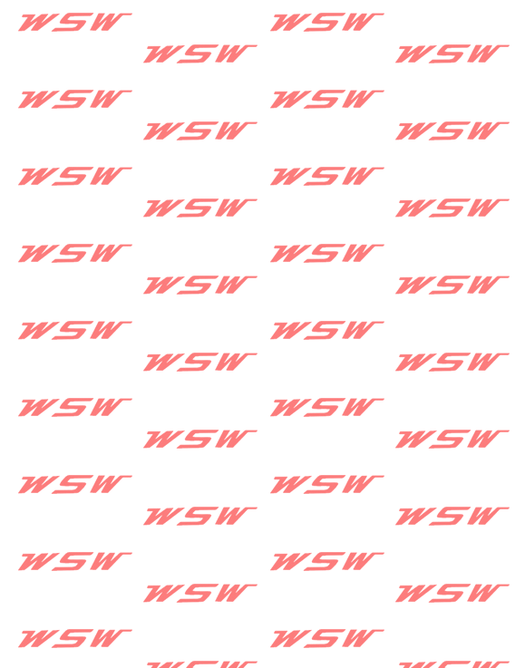
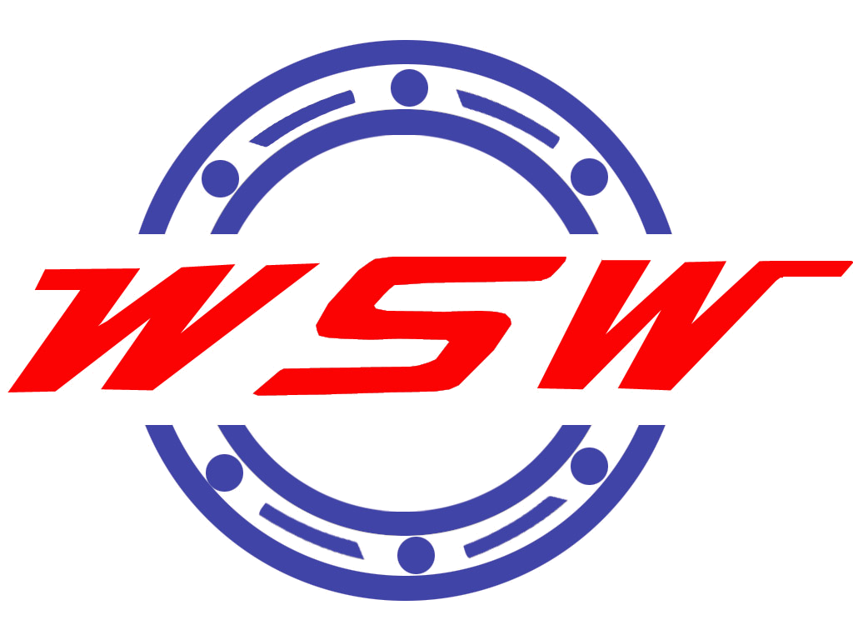

Guangda Bearing

Wafangdian Guangda Bearing Making Co., Ltd is locate in WaFangDian,Which in the north of LiaoNing province with the reputation of Bearing industry cradle in china.
Our company have nine types ,more than two hundreds series and five thousands varieties productions.Including that: : Deep Groove Ball Bearings(DGBB). Cylinder Roller Bearings(CRB). Self -aligning Roller Bearings(SRB). Angular Contact Ball Bearings(ACBB). Taper Roller Bearings(TRB). Thrust Taper Roller Bearings(TH-TRB). Spherical Plain Bearings(SPB). Slewing Bearings(SLB), Thrust Spherical Roller Bearings(SRTB),And according to the customers to design and produce the Non-standard Bearings.Our production are apply to the Metallurgy.Mine.Mechanism. Petroleum.Chemical.Automative.Paper making.Cement.etc.We have the the right of imports and exports and want to coordinate with internal and overseas customers to achieve the profit of bilateral.

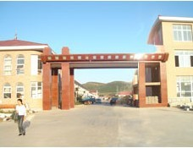
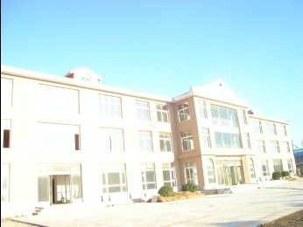
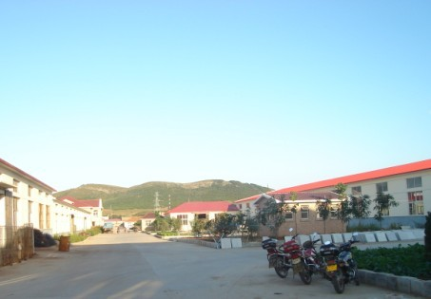

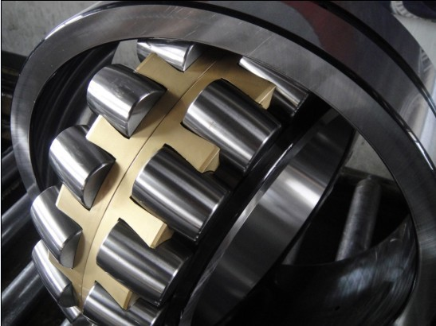
Contact Us
Phone：+86-411-85505930/+86-411-85590787
Cellphone:13942057339
Fax：+86-411-85517667
E-MAIL：wsw@gd-wsw.com
Website: http://www.gd-wsw.com
Address：Zhuhua Office San jia Industrial Park,Wa Fangdian
MSN: wonderful_song@tom.com
Zip code：116300

